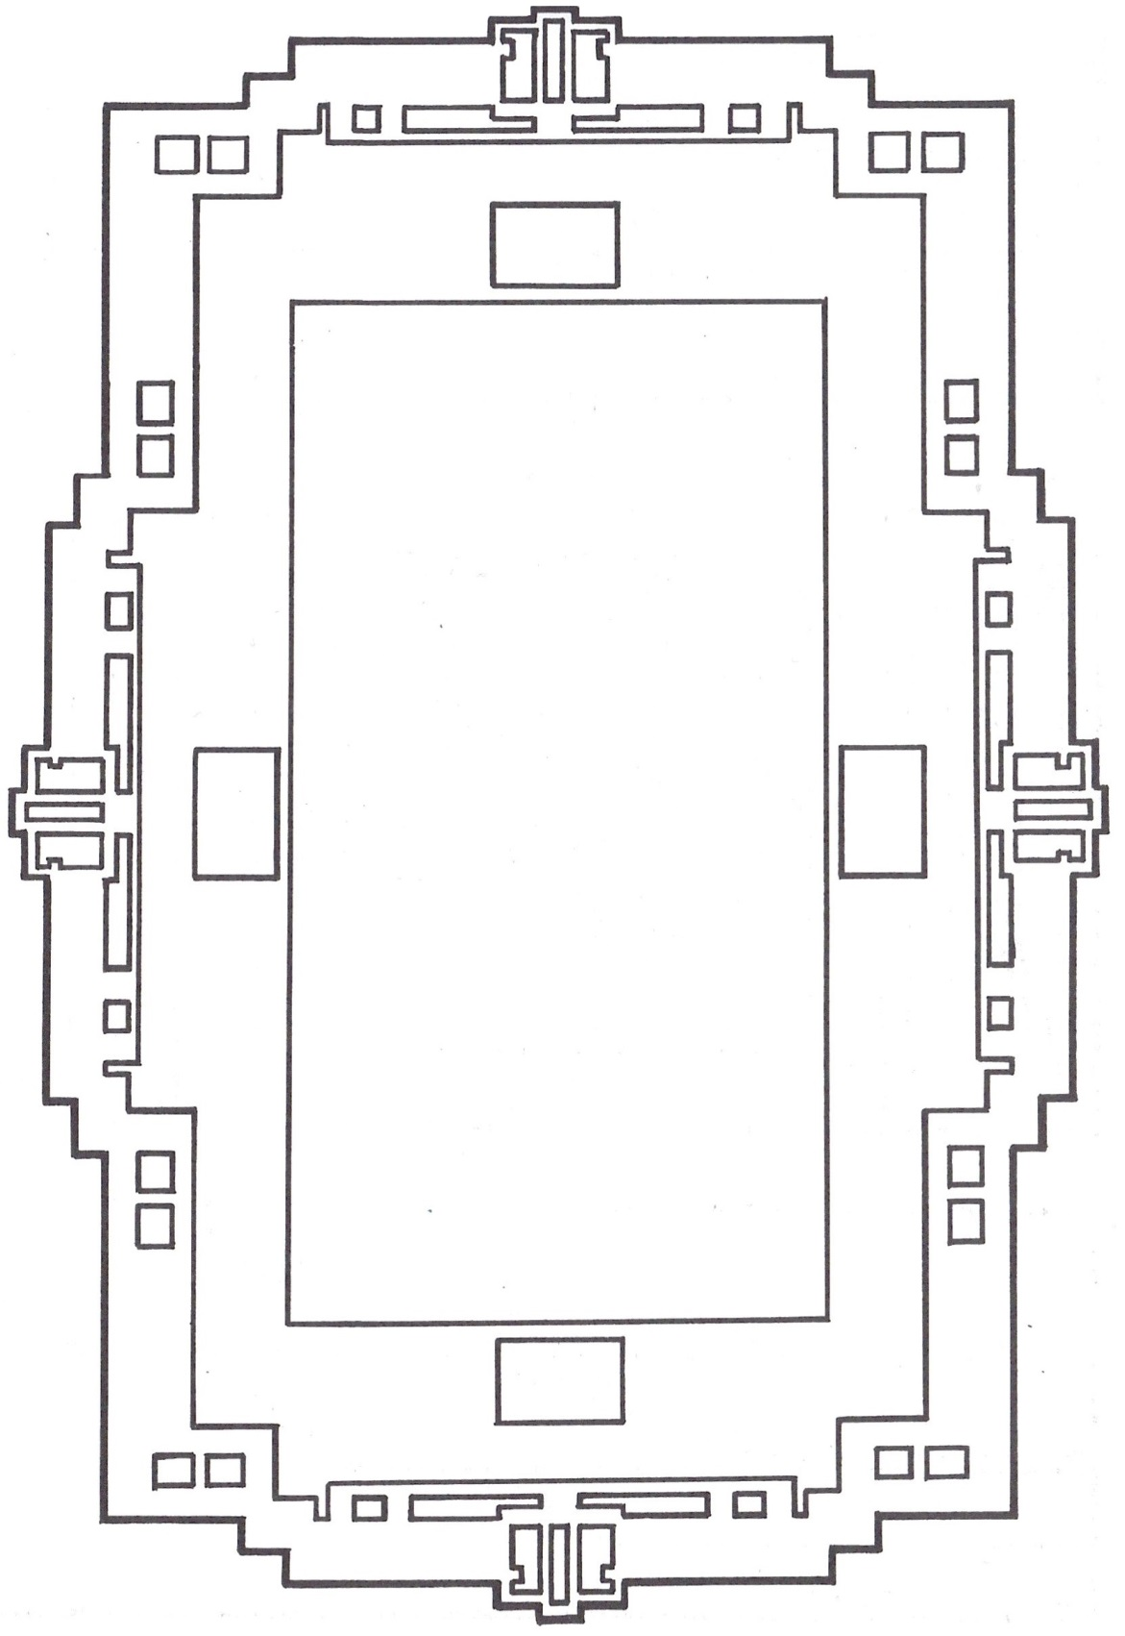

[YOUR NAME/ORGANIZATION HERE]

**invites you to a…**

# **Roarin’ 20’s Murder Mystery Dinner**

**“Who Invited The Stiff To Dinner?”**

Date

Time

Location

Come in costume or elegant attire.

Tickets are $_____ each.

Childcare will be provided for a nominal fee.

Please RSVP by [DATE]

[NAME & PHONE #]

[YOUR NAME/ORGANIZATION HERE]

**invites you to a…**

# **Roarin’ 20’s Murder Mystery Dinner**

**“Who Invited The Stiff To Dinner?”**

Date

Time

Location

Come in costume or elegant attire.

Tickets are $_____ each.

Childcare will be provided for a nominal fee.

Please RSVP by [DATE]

[NAME & PHONE #]

The Dramatic Pen

The Dramatic Pen